Package Title: Testbank
Course Title: PAP15
Chapter Number: 01
Shuffle: Yes
Case Sensitive: No

Question type: Multiple Choice

1) Which describes the study of the functions of body structures?

a) anatomy
b) physiology
c) endocrinology
d) histology
e) immunology

Answer: b

Difficulty: Easy
Bloomcode: Knowledge
Learning Objective 1: LO 1.1 Define anatomy and physiology, and name several branches of these sciences.
Section Reference 1: Sec 1.1 Anatomy and Physiology Defined

Question type: Multiple Choice

2) A group of cells that work together to perform a particular function is a(n)

a) tissue
b) organ
c) molecules
d) compounds
e) organism

Answer: a

Difficulty: Easy
Bloomcode: Knowledge
Learning Objective 1: LO1.2 Identify the locations and functions of each of the organ systems and major organs of the human body.
Learning Objective 2: LO1.2.1 Describe the body’s six levels of structural organization.
Section Reference 1: Sec 1.2 Levels of Structural Organization and Body Systems.

Question type: Multiple Selection

3) What process occurs when amino acids build new proteins

a) metabolism
b) anabolism
c) catabolism
d) responsiveness
e) differentiation

Answer 1: a
Answer 2: b

Difficulty: Medium
Bloomcode: Application
Learning Objective 1: LO1.3.1 Define the important life processes of the human body.
Section Reference 1: Sec 1.3 Characteristics of the Living Human Organism

Question type: Essay

4) How are reproduction, differentiation and growth related?

Answer:

Difficulty: Hard
Bloomcode: Synthesis
Learning Objective 1: LO1.3.1 Define the important life processes of the human body.
Section Reference 1: Sec 1.3 Characteristics of the Living Human Organism
Solution: Reproduction occurs through the fertilization of an ovum by a sperm cell to form a zygote, followed by repeated cell divisions and the differentiation of these cells. Growth is an increase in body size that results from an increase in the size of existing cells, an increase in the number of cells, or both.

Question type: Multiple Choice

5) The two organ systems that predominantly regulate and maintain homeostasis are the

a) cardiovascular and integumentary systems.
b) nervous and endocrine systems.
c) cardiovascular and respiratory systems.
d) respiratory and muscular systems.
e) urinary and integumentary systems.

Answer: b

Difficulty: Easy
Bloomcode: Comprehension
Learning Objective 1: LO1.4.1 Define homeostasis.
Section Reference 1: Sec 1.4 Homeostasis

6) Which body fluid fills the narrow spaces between cells and tissues?

a) lymph
b) blood plasma
c) interstitial fluid
d) intracellular fluid
e) vitreous body

Answer: c

Difficulty: Medium
Bloomcode: Application
Learning Objective 1: LO1.4.1 Define homeostasis
Section Reference 1: Sec 1.4 Homeostasis

Question type: Essay

7) Describe the differences between positive and negative feedback systems.

Answer:

Difficulty: Medium
Bloomcode: Analysis
Learning Objective 1: LO1.4.2 Describe the components of a feedback system.
Learning Objective 2: LO1.4.3 Contrast the operation of negative and positive feedback systems.
Section Reference 1: Sec 1.4 Homeostasis
Solution: A positive feedback system will strengthen or reinforce a change in one of the body’s controlled conditions while a negative feedback system will reverse a change in a controlled condition.

Question type: Multiple Choice

8) Hormonal or electrical signals are sent from the control center to the

a) receptors
b) stimulus
c) afferent pathway
d) effectors
e) efferent pathway

Answer: d

Difficulty: Medium
Bloomcode: Application
Learning Objective 1: LO1.4.2 Describe the components of a feedback system.
Section Reference 1: Sec 1.4 Homeostasis

Question type: Multiple Choice

9) A component that detects decreasing oxygen concentrations in blood would be the

a) receptor
b) muscle
c) response
d) effector

Answer: a

Difficulty: Medium
Bloomcode: Analysis
Learning Objective 1: LO1.4.2 Describe the components of a feedback system.
Section Reference 1: Sec 1.4 Homeostasis

Question type: Multiple Choice

10) If blood concentrations of thyroid hormones increase above a certain level, Thyroid releasing hormone (TRH) neurons in the hypothalamus are inhibited and stop secreting TRH. This is an example of

a) negative feedback
b) positive feedback

Answer: a

Difficulty: Hard
Bloomcode: Evaluation
Learning Objective 1: LO1.4.3 Contrast the operation of negative and positive feedback systems.
Section Reference 1: Sec 1.4 Homeostasis

Question type: Multiple-Selection

11) Cardiomyopathy worsens as the heart weakens. Swelling in the legs occurs and is classified as a… (Select all that apply)

a) symptom.
b) disorder.
c) disturbance.
d) disease.
e) sign.

Answer 1: b
Answer 2: c
Answer 3: e

Difficulty: Medium
Bloomcode: Analysis
Learning Objective 1:.SO 1.4.4 Explain how homeostatic imbalances are related to disorders
Section Reference 1: Sec 1.4 Homeostasis

Question type: Essay

12) Describe the anatomical position.

Answer:

Difficulty: Easy
Bloomcode: Comprehension
Learning Objective 1: LO1.5 Describe the human body using the anatomical position and specific anatomical terminology.
Learning Objective 2: LO1.5.1 Describe the anatomical position.
Section Reference 1: Sec 1.5 Basic Anatomical Terminology
Solution: In the anatomical position, the subject stands erect facing the observer with the head level and the eyes facing forward. The feet are flat on the floor and directed forward and the arms are at the sides with the palms turned forward.

Question type: Multiple Choice

13) Put the cavities in order from broadest to most specific in which the lungs are located

a) thoracic, ventral ,parietal pleura, visceral pleura
b) ventral, visceral pleura, thoracic, parietal pleura,
c) ventral, thoracic, parietal pleura, visceral pleura
d) thoracic, ventral, visceral pleura, parietal pleura

Answer: c

Difficulty: Medium
Bloomcode: Analysis
Learning Objective 1: LO1.5 Describe the human body using the anatomical position and specific anatomical terminology.
Learning Objective 2: LO1.5.4 Outline the major body cavities, the organs they contain, and their associated linings.
Section Reference 1: Sec 1.5 Basic Anatomical Terminology

Question type: Multiple Choice

14) Put the cavities in order from broadest to most specific in which the urinary bladder is located

a) ventral, abdominopelvic, pelvic, parietal peritoneal, visceral peritoneal
b) abdominopelvic, ventral. pelvic, visceral peritoneal, parietal peritoneal
c) ventral, abdominopelvic, visceral peritoneal, pelvic, parietal peritoneal
d) abdominopelvic, pelvic, ventral, parietal peritoneal, visceral peritoneal

Answer: a

Difficulty: Medium
Bloomcode: Application
Learning Objective 1: LO1.5 Describe the human body using the anatomical position and specific anatomical terminology.
Learning Objective 2: LO1.5.4 Outline the major body cavities, the organs they contain, and their associated linings.
Section Reference 1: Sec 1.5 Basic Anatomical Terminology

Question type: Multiple Choice

15) Which cavity contains the heart?

a) cranial cavity
b) vertebral cavity
c) abdominal cavity
d) pericardial cavity
e) pleural cavity

Answer: d

Difficulty: Easy
Bloomcode: Knowledge
Learning Objective 1: LO1.5 Describe the human body using the anatomical position and specific anatomical terminology.
Learning Objective 2: LO1.5.4 Outline the major body cavities, the organs they contain, and their associated linings.
Section Reference 1: Sec 1.5 Basic Anatomical Terminology

Question type: Multiple Choice

16) The function of the secretions of the pleura, is to…

a) separate the thoracic and abdominal cavities.
b) protect the central nervous system.
c) prevent infection.
d) reduce friction between neighboring organs.
e) carry nervous impulses.

Answer: d

Difficulty: Medium
Bloomcode: Application
Learning Objective 1: LO1.5 Describe the human body using the anatomical position and specific anatomical terminology.
Learning Objective 2: LO1.5.4 Outline the major body cavities, the organs they contain, and their associated linings.
Section Reference 1: Sec 1.5 Basic Anatomical Terminology

Question type: Multiple Choice

17) Cutting open the chest at the sternal marking would represent a(n)

a) sagittal plane
b) midsagittal plane
c) transverse plane
d) oblique plane
e) coronal plane

Answer: b

Difficulty: Medium
Bloomcode: Analysis
Learning Objective 1: LO1.5 Describe the human body using the anatomical position and specific anatomical terminology.
Learning Objective 2: LO1.5.3 Define the anatomical planes, anatomical sections, and directional terms used to describe the human body.
Section Reference 1: Sec 1.5 Basic Anatomical Terminology

Question type: Multiple Choice

18) Amputation of the arm at the shoulder would be a(n)

a) frontal plane
b) parasagittal plane
c) transverse plane
d) oblique plane
e) midsagittal plane

Answer: b

Difficulty: Medium
Bloomcode: Analysis
Learning Objective 1: LO1.5 Describe the human body using the anatomical position and specific anatomical terminology.
Learning Objective 2: LO1.5.3 Define the anatomical planes, anatomical sections, and directional terms used to describe the human body.
Section Reference 1: Sec 1.5 Basic Anatomical Terminology

Question type: Multiple Choice

19) Cutting the body in half at the diaphragm, would create the thoracic cavity and the abdominopelvic cavity. What plane would create these halves?

a) frontal
b) sagittal
c) transverse
d) oblique
e) midsagittal

Answer: c

Difficulty: Medium
Bloomcode: Analysis
Learning Objective 1: LO1.5 Describe the human body using the anatomical position and specific anatomical terminology.
Learning Objective 2: LO1.5.3 Define the anatomical planes, anatomical sections, and directional terms used to describe the human body.
Section Reference 1: Sec 1.5 Basic Anatomical Terminology

Question type: Multiple Choice

20) When holding your arms out to the side at shoulder level, your fingers are ________from your midline.

a) medial
b) anterior
c) proximal
d) posterior
e) lateral

Answer: e

Difficulty: Medium
Bloomcode: Application
Learning Objective 1: LO1.5 Describe the human body using the anatomical position and specific anatomical terminology.
Learning Objective 2: LO1.5.3 Define the anatomical planes, anatomical sections, and directional terms used to describe the human body.
Section Reference 1: Sec 1.5 Basic Anatomical Terminology

Question type: Multiple Choice

21) When your fingers touch your shoulder, they are considered________from the shoulder?

a) proximal
b) contralateral
c) lateral
d) superficial
e) distal

Answer: e

Difficulty: Hard
Bloomcode: Application
Learning Objective 1: LO1.5 Describe the human body using the anatomical position and specific anatomical terminology.
Learning Objective 2: LO1.5.3 Define the anatomical planes, anatomical sections, and directional terms used to describe the human body.
Section Reference 1: Sec 1.5 Basic Anatomical Terminology

Question type: Multiple Choice

22) Choose the directional term that would make the following sentence correct. The heart is _____ to the liver.

a) inferior
b) anterior
c) contralateral
d) superior
e) superficial

Answer: d

Difficulty: Medium
Bloomcode: Application
Learning Objective 1: LO1.5 Describe the human body using the anatomical position and specific anatomical terminology.
Learning Objective 2: LO1.5.3 Define the anatomical planes, anatomical sections, and directional terms used to describe the human body.
Section Reference 1: Sec 1.5 Basic Anatomical Terminology

Question type: Multiple Choice

23) Choose the directional term that would make the following sentence correct. The sternum is _____ to the heart.

a) posterior
b) anterior
c) inferior
d) superior
e) lateral

Answer: b

Difficulty: Medium
Bloomcode: Application
Learning Objective 1: LO1.5 Describe the human body using the anatomical position and specific anatomical terminology.
Learning Objective 2: LO1.5.3 Define the anatomical planes, anatomical sections, and directional terms used to describe the human body.
Section Reference 1: Sec 1.5 Basic Anatomical Terminology

Question type: Multiple Choice

24) In the figure, the ascending colon and the gallbladder are considered ________to each other

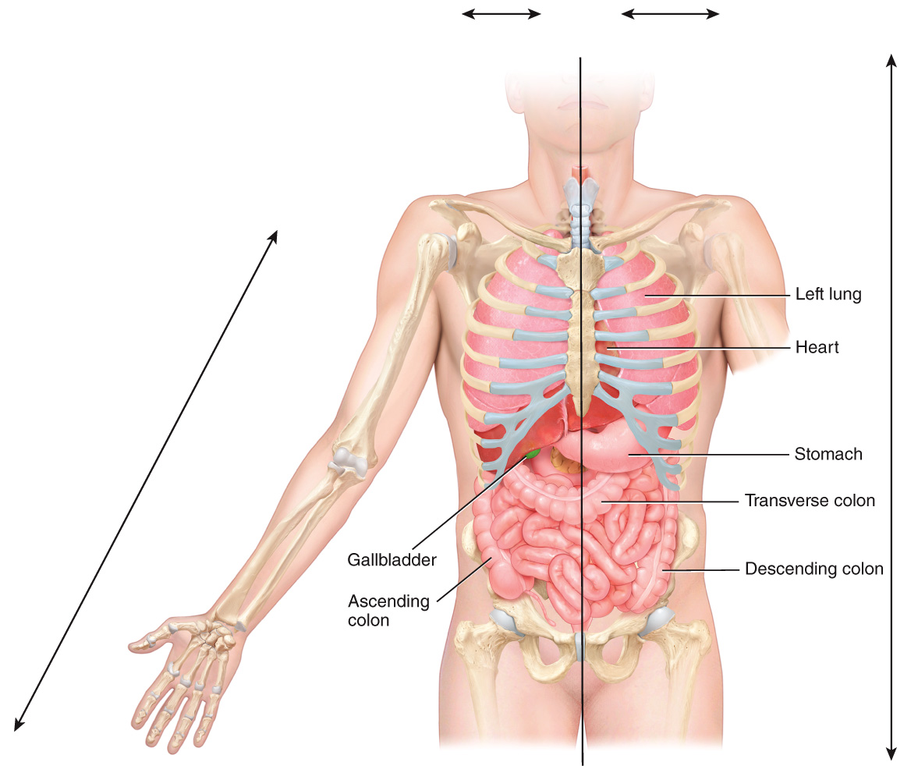

a) ipsilateral
b) contralateral
c) lateral
d)distal
e) posterior

Answer: a

Difficulty: Medium
Bloomcode: Application
Learning Objective 1: LO1.5 Describe the human body using the anatomical position and specific anatomical terminology.
Learning Objective 2: LO1.5.4 Outline the major body cavities, the organs they contain, and their associated linings.
Section Reference 1: Sec 1.5 Basic Anatomical Terminology

Question Type: Multiple-Selection

25) Which two organs in the diagram are in the abdominal cavity? Select all that apply.

a) liver
b) stomach
c) lung
d) heart
e) transverse colon

Answer 1: a
Answer 2: b
Answer 3: e

Difficulty: Medium
Bloomcode: Application
Learning Objective 1: LO1.5 Describe the human body using the anatomical position and specific anatomical terminology.
Learning Objective 2: LO1.5.4 Outline the major body cavities, the organs they contain, and their associated linings.
Section Reference 1: Sec 1.5 Basic Anatomical Terminology

Question Type: Multiple Choice

26) In the diagram, the femoral area is _____to the cervical area?
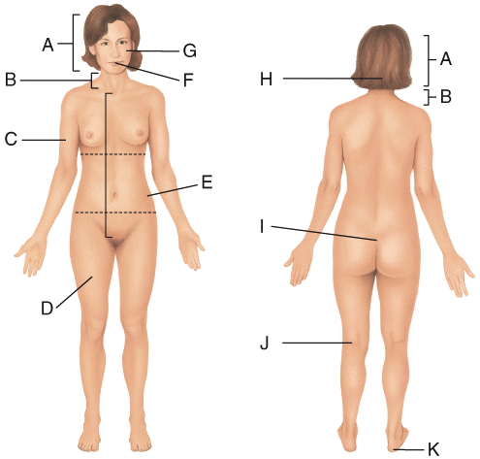

a) superior
b) inferior
c) medial
d) proximal
e) posterior

Answer: b

Difficulty: Hard
Bloomcode: Evaluation
Learning Objective 1: LO1.5 Describe the human body using the anatomical position and specific anatomical terminology.
Learning Objective 2: LO1.5.3 Define the anatomical planes, anatomical sections, and directional terms used to describe the human body.
Section Reference 1: Sec 1.5 Basic Anatomical Terminology

Question Type: Multiple Choice

27) In the diagram, the calcaneal is _____to the popliteal region?

a) ipsilateral
b) contralateral
c) superior
d) anterior
e) medial

Answer: b

Difficulty: Hard
Bloomcode: Evaluation
Learning Objective 1: LO1.5 Describe the human body using the anatomical position and specific anatomical terminology.
Learning Objective 2: LO1.5.3 Define the anatomical planes, anatomical sections, and directional terms used to describe the human body.
Section Reference 1: Sec 1.5 Basic Anatomical Terminology

Question Type: Multiple Choice

28) The ribs are _____ to the sternum.
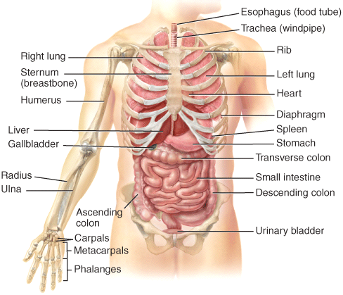

a) lateral
b) medial
c) proximal
d) distal
e) superior

Answer: a

Difficulty: Medium
Bloomcode: Application
Learning Objective 1: LO1.5 Describe the human body using the anatomical position and specific anatomical terminology.
Learning Objective 2: LO1.5.3 Define the anatomical planes, anatomical sections, and directional terms used to describe the human body.
Section Reference 1: Sec 1.5 Basic Anatomical Terminology

Question type: Multiple Choice

29) The stomach is _____ to the urinary bladder.

a) lateral
b) medial
c) distal
d) inferior
e) superior

Answer: e

Difficulty: Medium
Bloomcode: Application
Learning Objective 1: LO1.5 Describe the human body using the anatomical position and specific anatomical terminology.
Learning Objective 2: LO1.5.3 Define the anatomical planes, anatomical sections, and directional terms used to describe the human body.
Section Reference 1: Sec 1.5 Basic Anatomical Terminology

Question type: Multiple Choice

30) Which plane divides the body into unequal right and left halves?
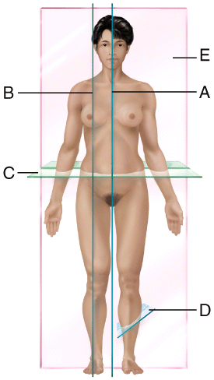

a) A
b) B
c) C
d) D
e) E

Answer: b

Difficulty: Medium
Bloomcode: Application
Learning Objective 1: LO1.5 Describe the human body using the anatomical position and specific anatomical terminology.
Learning Objective 2: LO1.5.3 Define the anatomical planes, anatomical sections, and directional terms used to describe the human body.
Section Reference 1: Sec 1.5 Basic Anatomical Terminology

Question type: Multiple Choice

31) Which plane would allow one to view the heart and lungs from a posterior view?

a) A
b) B
c) C
d) D
e) E

Answer: e

Difficulty: Medium
Bloomcode: Analysis
Learning Objective 1: LO1.5 Describe the human body using the anatomical position and specific anatomical terminology.
Learning Objective 2: LO1.5.3 Define the anatomical planes, anatomical sections, and directional terms used to describe the human body.
Section Reference 1: Sec 1.5 Basic Anatomical Terminology

Question type: Essay

32) Name the cavities of the trunk and the serous membranes that line them.

Answer:

Difficulty: Medium
Bloomcode: Application
Learning Objective 1: LO1.5 Describe the human body using the anatomical position and specific anatomical terminology.
Learning Objective 2: LO1.5.4 Outline the major body cavities, the organs they contain, and their associated linings.
Section Reference 3: 1.5 Basic Anatomical Terminology
Solution: The two main cavities of the trunk are the thoracic and abdominopelvic cavities. The thoracic cavity can be divided into three smaller cavities called the pericardial cavity, and two fluid-filled spaces called pleural cavities. The pericardial cavity is lined by the pericardium. The pleural cavity is lined by the pleura. The central part of the thoracic cavity is an anatomical region called the mediastinum. It is between the lungs, extending from the sternum to the vertebral column and from the first rib to the diaphragm. The abdominopelvic cavity can be divided into the abdominal and pelvic cavities, both of which are lined by the peritoneum.

Question type: Essay

33) Explain the relationship between the skeletal system and the urinary system?

Answer:

Difficulty: Hard
Bloomcode: Synthesis
Learning Objective 1: LO1.2 Identify the locations and functions of each of the organ systems and major organs of the human body.
Learning Objective 2: LO1.2.2 List the 11 systems of the human body, representative organs present in each, and their general functions
Section Reference 1: Sec 1.2 Levels of Structural Organization body systems.
Solution: The skeletal system supports and protects organs within the body, stores minerals. Within the bones are the cells that produce blood cells. The urinary system helps regulate the production of red blood cells and helps maintain the body’s mineral balance.

Question type: Essay

34) Name the structural levels of the body and briefly describe each level.

Answer:

Difficulty: Medium
Bloomcode: Application
Learning Objective 1: LO1.2 Identify the locations and functions of each of the organ systems and major organs of the human body.
Learning Objective 2: LO1.2.1 Describe the body’s six levels of structural organization.
Section Reference 1: Sec 1.2 Levels of Structural Organization body systems.
Solution: The chemical level consists of atoms and molecules. The cellular level consists of cells which are the smallest form of life. The tissue level consists of groups of cells that work to provide a single function. The organ level consists of organs, constructed from different types of tissue that can provide several different specific functions. The organ systems consist of one or more organs that are interlinked in general functions. The organism is made up of all the organ systems, which work to provide homeostasis.

Question type: Essay

35) List and briefly describe the six basic life processes.

Answer:

Difficulty: Medium
Bloomcode: Application
Learning Objective 1: LO1.3.1 Define the important life processes of the human body.
Section Reference 1: Sec 1.3 Characteristics of the Living Human Organism
Solution: The six basic life processes include: 1) Metabolism is the sum of all chemical processes in the body. 2) Responsiveness is the body’s ability to detect and respond to internal and external stimuli. 3) Movement includes motions that range from movements within individual cells to movement of the entire body. 4) Growth means an increase in body size or an increase in the number of cells. 5) Differentiation is the process that converts a cell from unspecialized to specialized. 6) Reproduction refers to formation of new cells for growth and repair or production of a new individual.

Question type: Essay

36) Describe a feedback system and list its general components.

Answer:

Difficulty: Medium
Bloomcode: Application
Learning Objective 1: LO1.4.2 Describe the components of a feedback system
Section Reference 1: Sec 1.4 Homeostasis
Solution: A feedback loop is a cycle of events in which the status of the body condition is monitored, evaluated and changed to maintain homeostasis. A feedback system will include a receptor that detects the stimuli, a control center that receives the input from the receptor and generates an output, and an effector that receives the output and produces a response.

Question type: Multiple Choice

37) Which noninvasive diagnostic techniques is an example of inspection?

a) tapping and listening for an echo to detect fluid in the lungs
b) feeling the abdomen to detect tender organs
c) listening for crackling sounds during breathing
d) examining the surface of patient’s skin for presence of a rash
e) feeling the gonads to detect abnormal masses

Answer: d

Difficulty: Medium
Bloomcode: Analysis
Learning Objective 1: LO1.2 Identify the locations and functions of each of the organ systems and major organs of the human body.
Learning Objective 2: LO1.2.2 List the 11 systems of the human body, representative organs present in each, and their general functions.
Section Reference 1: Sec 1.2 Levels of Structural Organization body systems.

Question type: Multiple Choice

38) Which subspecialty of physiology addresses pharmacology, chemistry and physiology of nervous tissue?

a) endocrinology
b) cardiovascular physiology
c) neurophysiology
d) immunology
e) pathophysiology

Answer: c

Difficulty: Easy
Bloomcode: Comprehension
Learning Objective 1: LO1.1 Define anatomy and physiology, and name several branches of these sciences.
Section Reference 1: Sec 1.1 Anatomy and Physiology Defined

Question type: Multiple Choice

39) Which subspecialty of physiology deals with the effects of hormones control of reproduction?

a) endocrinology
b) cardiovascular physiology
c) neurophysiology
d) immunology
e) pathophysiology

Answer: a

Difficulty: Easy
Bloomcode: Comprehension
Learning Objective 1: LO1.1 Define anatomy and physiology, and name several branches of these sciences.
Section Reference 1: Sec 1.1 Anatomy and Physiology Defined

Question type: Multiple Choice

40) If one was reviewing the pattern of tissue changes associated with disease development, they would be studying

a) exercise physiology
b) renal physiology
c) pathological anatomy
d) cardiovascular physiology
e) immunology

Answer: c

Difficulty: Medium
Bloomcode: Application
Learning Objective 1: LO1.1 Define anatomy and physiology, and name several branches of these sciences.
Section Reference 1: Sec 1.1 Anatomy and Physiology Defined

Question type: Multiple Choice

41) An antigen is anything that can cause an immune response. Which subspecialty of physiology deals with the study of these responses?

a) exercise physiology
b) renal physiology
c) pathophysiology
d) cardiovascular physiology
e) immunology

Answer: e

Difficulty: Medium
Bloomcode: Application
Learning Objective 1: LO1.1 Define anatomy and physiology, and name several branches of these sciences.
Section Reference 1: Sec 1.1 Anatomy and Physiology Defined

Question type: Multiple Choice

42) If a doctor listens to a gurgling noise within the gastrointestinal tract, they are performing

a) inspection
b) palpation
c) percussion
d) auscultation

Answer: d

Difficulty: Medium
Bloomcode: Analysis
Learning Objective 1: LO 1.2 Identify the locations and functions of each of the organ systems and major organs of the human body.
Section Reference 1: Sec 1.2 Levels of Structural Organization and Body Systems

Question type: Multiple Choice

43) If someone receives CPR, compressions will be performed on the ______area.

a) pelvic
b) umbilical
c) sternal
d) otic
e) inguinal

Answer: c

Difficulty: Medium
Bloomcode: Analysis
Learning Objective 1: LO1.5 Describe the human body using the anatomical position and specific anatomical terminology.
Learning Objective 2: LO1.5.2 Relate the anatomical names and the corresponding common names for various regions of the human body.
Section Reference 1: Sec 1.5 Basic Anatomical Terminology

Question type: Multiple Choice

44) Blood is often drawn from the front of the elbow or the _______ marking.

a) olecranal
b) antecubital
c) carpal
d) digital
e) antebrachial

Answer: b

Difficulty: Medium
Bloomcode: Application
Learning Objective 1: LO1.5 Describe the human body using the anatomical position and specific anatomical terminology.
Learning Objective 2: LO1.5.2 Relate the anatomical names and the corresponding common names for various regions of the human body.
Section Reference 1: Sec 1.5 Basic Anatomical Terminology

Question type: Multiple Choice

45) Swimmers ear is an infection in the outer ear canal. What anatomical term refers to the area infected?

a) otic
b) orbital
c) ocular
d) oral
e) occipital

Answer: a

Difficulty: Medium
Bloomcode: Analysis
Learning Objective 1: LO1.5 Describe the human body using the anatomical position and specific anatomical terminology.
Learning Objective 2: LO1.5.2 Relate the anatomical names and the corresponding common names for various regions of the human body.
Section Reference 1: Sec 1.5 Basic Anatomical Terminology

Question type: Multiple Choice

46) Bunions are awful painful, pressure-sensitive areas that lead to displacement of the big toe. What term refers to the big toe?

a) pollex
b) tarsal
c) hallux
d) pedal
e) carpal

Answer: c

Difficulty: Medium
Bloomcode: Application
Learning Objective 1: LO1.5 Describe the human body using the anatomical position and specific anatomical terminology.
Learning Objective 2: LO1.5.2 Relate the anatomical names and the corresponding common names for various regions of the human body.
Section Reference 1: Sec 1.5 Basic Anatomical Terminology

Question type: Multiple Choice

47) Abductor pollicis longus and extensor pollicis brevis are muscles that help move what anatomical marking?

a) pollex
b) tarsal
c) hallux
d) volar
e) carpal

Answer: a

Difficulty: Hard
Bloomcode: Evaluation
Learning Objective 1: LO1.5 Describe the human body using the anatomical position and specific anatomical terminology.
Learning Objective 2: LO1.5.2 Relate the anatomical names and the corresponding common names for various regions of the human body.
Section Reference 1: Sec 1.5 Basic Anatomical Terminology

Question type: Multiple Choice

48) The section shown in (C) results from cutting through a _____ plane extending through the brain?
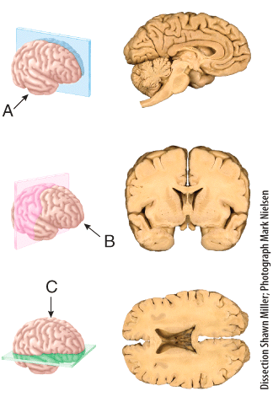

a) frontal
b) sagittal
c) oblique
d) midsagittal
e) transverse

Answer: e

Difficulty: Medium
Bloomcode:Analysis
Learning Objective 1: LO1.5 Describe the human body using the anatomical position and specific anatomical terminology.
Learning Objective 2: LO1.5.2 Relate the anatomical names and the corresponding common names for various regions of the human body .
Section Reference 1: Sec 1.5 Basic Anatomical Terminology

Question type: Multiple Choice

49) The section shown in (B) results from cutting through a _______ plane extending through the brain?

a) frontal
b) sagittal
c) oblique
d) midsagittal
e) transverse

Answer: a

Difficulty: Medium
Bloomcode: Analysis
Learning Objective 1: LO1.5 Describe the human body using the anatomical position and specific anatomical terminology.
Learning Objective 2: LO1.5.2 Relate the anatomical names and the corresponding common names for various regions of the human body.
Section Reference 1: Sec 1.5 Basic Anatomical Terminology

Question type: Multiple Choice

50) Which cavity contains the urinary bladder?
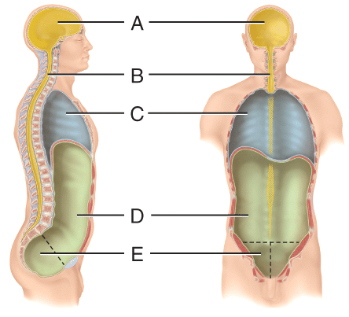

a) (A)
b) (B)
c) (C)
d) (D)
e) (E)

Answer: e

Difficulty: Easy
Bloomcode: Comprehension
Learning Objective 1: LO1.5 Describe the human body using the anatomical position and specific anatomical terminology.
Learning Objective 2: LO1.5.2 Relate the anatomical names and the corresponding common names for various regions of the human body.
Section Reference 1: Sec 1.5 Basic Anatomical Terminology

51) What physically separates the area labelled C from the area labeled D?

a) visceral peritoneum
b) mediastinum
c) meninges
d) parietal pericardial
e) diaphragm

Answer: e

Difficulty: Easy
Bloomcode: Comprehension
Learning Objective 1: LO1.5 Describe the human body using the anatomical position and specific anatomical terminology.
Learning Objective 2: LO1.5.2 Relate the anatomical names and the corresponding common names for various regions of the human body.
Section Reference 1: Sec 1.5 Basic Anatomical Terminology

Question type: Multiple-Selection

52) Which cavity is lined by serous membranes. Select all that apply?

a) A
b) B
c) C
d) D
e) E

Answer 1: c
Answer 2: d
Answer 3: e

Difficulty: Medium
Bloomcode: Application
Learning Objective 1: LO1.5 Describe the anatomical position and how anatomical terms are used to describe the human body.
Learning Objective 2: LO1.5.4 Outline the major body cavities, the organs they contain, and their associated linings.
Section Reference 1: Sec 1.5 Basic Anatomical Terminology

Question Type: Multiple Choice

53) Which cavity contains the main control centers in the feedback cycle?

a) (A)
b) (C)
c) (D)
d) (E)

Answer 1: a

Difficulty: Medium
Bloomcode: Application
Learning Objective 1: LO1.5 Describe the anatomical position and how anatomical terms are used to describe the human body.
Learning Objective 2: LO1.5 4 Outline the major body cavities, the organs they contain, and their associated linings.
Section Reference 1: Sec 1.5 Basic Anatomical Terminology

54) The pericardial cavity is located inside the

a) parietal pleura
b) visceral pleura
c) parietal periotneum
d) visceral peritoneum
e) mediastinum

Answer: e

Difficulty: Medium
Bloomcode:Application
Learning Objective 1: LO1.5 Describe the human body using the anatomical position and specific anatomical terminology.
Learning Objective 2: LO1.5.4 Outline the major body cavities, the organs they contain, and their associated linings.
Section Reference 1: Sec 1.5 Basic Anatomical Terminology

55) What cavity contains the kidneys, adrenal glands, pancreas and the duodenum?

a) retroperitoneal
b) visceral pleura
c) parietal pericardium
d) visceral peritoneum
e) mediastinum

Answer: a

Difficulty: Medium
Bloomcode:Application
Learning Objective 1: LO1.5 Describe the human body using the anatomical position and specific anatomical terminology.
Learning Objective 2: LO1.5.4 Outline the major body cavities, the organs they contain, and their associated linings.
Section Reference 1: Sec 1.5 Basic Anatomical Terminology

56) According to the diagram, an appendectomy would be performed

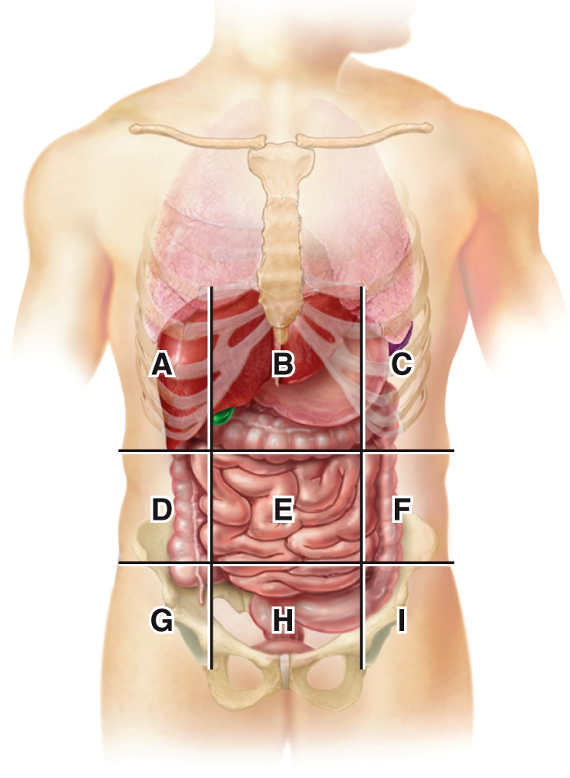

a) B
b) D
c) G
d) H
e) I

Answer: c

Difficulty: Easy
Bloomcode: Comprehension
Learning Objective 1: LO1.5 Describe the human body using the anatomical position and specific anatomical terminology.
Learning Objective 2: LO1.5.4 Outline the major body cavities, the organs they contain, and their associated linings.
Section Reference 1: Sec 1.5 Basic Anatomical Terminology

57) A patient has a laparoscopic cholecystectomy (gallbladder removal). Which abdominopelvic region would the doctor perform surgery
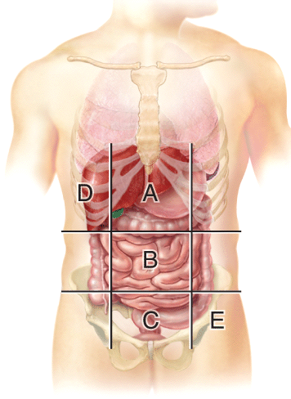

a) A
b) B
c) C
d) D
e) E

Answer: a

Difficulty: Medium
Bloomcode: Analysis
Learning Objective 1: LO1.5 Describe the anatomical position and how anatomical terms are used to describe the human body.
Learning Objective 2: LO1.5.4 Outline the major body cavities, the organs they contain, and their associated linings.
Section Reference 1: Sec 1.5 Basic Anatomical Terminology
58) Which radiographs were obtained using low-dose x-rays?
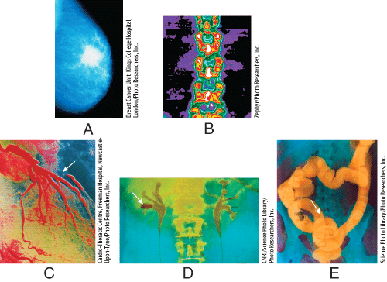

a) (A) and (B)
b) (B) and (C)
c) (C) and (D)
d) (A) and (C)
e) (B) and (E)

Answer: a

Difficulty: Medium
Bloomcode: Application
Learning Objective 1: LO1.6 Describe the principles and importance of medical imaging procedures in the evaluation of organ functions and the diagnosis of disease.
Section Reference 1: Sec 1.6 Medical Imaging

Question type: Essay

59) Discuss the importance of body fluids and which one is considered to be the body’s internal environment.

Answer:

Difficulty: Medium
Bloomcode: Analysis
Learning Objective 1: LO1.3 Define the important processes.
Learning Objective 2 LO 1.3.2 Define homeostasis and explain its relationship to interstitial fluid.
Section Reference 1: Sec 1.4 Homeostasis
Solution: An important aspect of homeostasis is maintaining the volume and composition of body fluids, which are dilute, watery solutions containing the dissolved substances needed to sustain life. The fluid within cells is intracellular fluid (ICF) and the fluid found outside of cells is extracellular fluid (ECF). The ECF consists of interstitial fluid, blood plasma, lymph, cerebrospinal fluid, synovial fluid, aqueous humor, and vitreous. The ECF called interstitial fluid, which is the fluid found in the narrow spaces between cells and tissues, is also known as the body’s internal environment. This is due to the fact that the proper functioning of body cells depends on precise regulation of the composition of the interstitial fluid surrounding them.

Question type: Multiple Choice

60) Which examples exhibit the basic life process of growth?
1. muscle contraction
2. digestion of proteins
3. lifting weights and gaining muscle mass
4. mineral deposits accumulating between bone cells to cause a bone to lengthen

a) 1 only
b) 2 only
c) 3 only
d) 4 only
e) 3 and 4

Answer: e

Difficulty: Hard
Bloomcode: Evaluation
Learning Objective 1: LO1.3 Define the important processes of the human body.
Learning Objective 2: LO1.3.1 Define the important life processes of the human body.
Section Reference 1: Sec 1.3 Characteristics of the Living Human Organism

Question type: Text Drop Down

61) Feeling the presence of a mosquito biting your arm is an example of ______; Itching the mosquito bite is an example of ____________.

Dropdown choices:
differentiation
growth
movement
reproduction
responsiveness

Answer 1: responsiveness
Answer 2: movement

Difficulty: Medium
Bloomcode: Analysis
Learning Objective 1: LO1.3 Define the important life processes.
Learning Objective 2: LO1.3.1 Define the important life processes of the human body.
Section Reference 1: Sec 1.3 Characteristics of the Living Human Organism

Question type: Multiple Choice

62) During a visit to your doctor, you complain about headache and anxiety. These changes in your body functions are considered

a) signs.
b) symptoms.
c) receptors.
d) controlled condition.
e) responsiveness.

Answer: b

Difficulty: Easy
Bloomcode: Comprehension
Learning Objective 1: LO1.4.4 Explain how homeostatic imbalances are related to disorders.
Section Reference 1: Sec 1.4 Homeostasis

63) _____occurs when an embryonic stem cell becomes a neuron.

a) catabolism
b) growth
c) reproduction
d) anabolism
e) differentiation

Answer: e

Difficulty: Medium
Bloomcode: Analysis
Learning Objective 1: LO1.3 Define the important processes of the human body
Learning Objective 2: LO1.3.1 Define the important life processes of the human body.
Section Reference 1: Sec 1.3 Characteristics of the Living Human Organism

Question type: Multiple-Selection

64) Which body process is controlled using a positive feedback loop? Select all that apply

a) decreasing blood calcium in response to elevated blood calcium
b) decreasing body temperature in response to elevated body temperature
c) decreasing blood glucose in response to elevated blood glucose
d) increasing strength of uterine contractions in response to cervical stretch
e) decreasing heart rate in response to elevated blood pressure
f) depolarization causes sodium channels to open and the opening of sodium channels causes the membrane to depolarize

Answer 1: d
Answer 2: f

Difficulty: Hard
Bloomcode: Evaluation
Learning Objective 1: LO1.4.3 Contrast the operation of negative and positive feedback systems.
Section Reference 1: Sec 1.4 Homeostasis

Question type: Multiple Choice

65) Which organ contains the control center for the feedback system that regulates blood pressure?

a) skin
b) arteries
c) brain
d) heart
e) pituitary gland

Answer: c

Difficulty: Medium
Bloomcode: Application
Learning Objective 1: LO1.4.2 Describe the components of a feedback system.
Section Reference 1: Sec 1.4 Homeostasis

Question type: Multiple-Selection

66) What are common characteristic of a negative feedback system? Select all that apply

- regulates conditions in body that remain fairly stable over long periods
b) a self-amplifying cycle where a physiological change leads to even greater change in the same direction.
c) important in maintaining homeostasis
d) involves control centers in the nervous or endocrine systems
e) stimulates changes that reverse the direction of the stimulus
f) rate of a process increases as the concentration of the product increases

Answer 1: a
Answer 2: c
Answer 3: d
Answer 4: e

Difficulty: Hard
Bloomcode: Synthesis
Learning Objective 1: LO1.4.3 Contrast the operation of negative and positive feedback systems.
Section Reference 1: Sec 1.4 Homeostasis

Question Type: Multiple Choice

67) Place the following levels of organization from the most complex to the simplest level of organization.

a) chemical level, tissue level, cellular level, organismal level organ level,
b) chemical level, cellular level, tissue level, organ level, organismal level
c) cellular level, tissue level, organ level, chemical level, organismal level
d) chemical level, organ level, cellular level, tissue level, organismal level
Answer: b

Difficulty: Medium
Bloomcode: Application
Learning Objective 1: LO1.2 Identify the locations and functions of each of the organ systems and major organs of the human body.
Learning Objective 2: LO1.2.1 Describe the body’s six levels of structural organization.
Section Reference 1: Sec 1.2 Levels of Structural Organization body systems.

68) Which tissue will form the top layer of the skin?

a) epithelial tissue
b) connective tissue
c) muscular tissue
d) necrotic tissue
e) nervous tissue

Answer: a

Difficulty: Medium
Bloomcode: Analysis
Learning Objective 1: LO1.2 Identify the locations and functions of each of the organ systems and major organs of the human body.
Learning Objective 2: LO1.2.1 Describe the body’s six levels of structural organization.
Section Reference 1: Sec 1.2 Levels of Structural Organization and Body Systems.

69) Based on the correct levels of organization, why is the skin considered an organ?

a) chemical - cellular - tissue - organ - organ system – organism. Organs interact to form systems.
b) cellular - chemical - tissue - organ - organ system – organism. Organs are a combination of cells.
c) organism - organ system - organ - tissue - cellular – chemical. Organs are a combination of tissues.
d) Organs are a combination of molecules.

Answer: c

Difficulty: Medium
Bloomcode: Analysis
Learning Objective 1: LO1.2 Identify the locations and functions of each of the organ systems and major organs of the human body.
Learning Objective 2: LO1.2.1 Describe the body’s six levels of structural organization.
Section Reference 1: Sec 1.2 Levels of Structural Organization body systems.

70) Which structure or region could one clearly see when you are viewing the anterior side of an individual standing in the standard anatomical position?

a) shoulder blade
b) palm of the hand
c) plantar surface of foot
d) popliteal region of the knee
e) gluteal region

Answer: b

Difficulty: Medium
Bloomcode: Analysis
Learning Objective 1: LO1.5 Describe the human body using the anatomical position and specific anatomical terminology.
Learning Objective 2: LO1.5.1 Describe the anatomical position.
Section Reference 1: Sec 1.5 Basic Anatomical Terminology

Question Type: Multiple-Selection

71) Which of the following structures or regions could you clearly see when you are viewing the posterior side of an individual standing in the standard anatomical position? Select all that apply.

a) shoulder blade
b) palm of the hand
c) plantar surface of foot
d) popliteal region of the knee
e) gluteal region

Answer 1: a
Answer 2: d
Answer 3: e

Difficulty: Medium
Bloomcode: Analysis
Learning Objective 1: LO1.5 Describe the human body using the anatomical position and specific anatomical terminology.
Learning Objective 2: LO1.5.1 Describe the anatomical position.
Section Reference 1: Sec 1.5 Basic Anatomical Terminology

Question Type: Multiple Choice

72) Measuring the movements of protons in a magnetic field is

a) computed tomography
b) magnetic resonance imaging
c) ultrasound scanning
d) radionuclide scanning
e) amniocentesis

Answer: b

Difficulty: Easy
Bloomcode: Knowledge
Learning Objective 1: LO1.7 Describe the principles and importance of medical imaging procedures in the evaluation of organ functions and the diagnosis of disease.
Section Reference 1: Sec 1.7 Medical Imaging

73) Mammography and bone densitometry are good examples of which medical imaging?

a) computed tomography
b) magnetic resonance imaging
c) ultrasound scanning
d) radionuclide scanning
e) low-dose radiography

Answer: e

Difficulty: Easy
Bloomcode: Comprehension
Learning Objective 1: LO 1.7 Describe the principles and importance of medical imaging procedures in the evaluation of organ functions and the diagnosis of disease.
Section Reference 1: Sec 1.7 Medical Imaging

74) Mothers are able to visualize a fetus during pregnancy through

a) computed tomography
b) magnetic resonance imaging
c) ultrasound scanning
d) radionuclide scanning
e) amniocentesis

Answer: c

Difficulty: Easy
Bloomcode: Knowledge
Learning Objective 1: LO 1.7 Describe the principles and importance of medical imaging procedures in the evaluation of organ functions and the diagnosis of disease.
Section Reference 1: Sec 1.7 Medical Imaging

75) Metabolism of the brain can be measured through
a) computed tomography
b) magnetic resonance imaging
c) ultrasound scanning
d) positron emission tomorography
e) low-dose radiography

Answer: d

Difficulty: Easy
Bloomcode: Comprehension
Learning Objective 1: LO1.7 Describe the principles and importance of medical imaging procedures in the evaluation of organ functions and the diagnosis of disease.
Section Reference 1: Sec 1.7 Medical Imaging

Question Type: Text Drop Down

76) Match the serous membrane with its location
Visceral pericardium: __________
Parietal peritoneum: __________
Parietal pleural: __________

Drop Down Choices:
adheres to the outside of the heart
lines the wall of the abdominopelvic cavity
lines the wall of the chest cavity

Answer 1: adheres to the outside of the heart
Answer 2: lines the wall of the abdominopelvic cavity
Answer 3: lines the wall of the chest cavity

Difficulty: Medium
Bloomcode: Application
Learning Objective 1: LO1.5 Describe the human body using the anatomical position and specific anatomical terminology.
Learning Objective 2: LO1.5.4 Outline the major body cavities, the organs they contain, and their associated linings.
Section Reference 1: Sec 1.5 Basic Anatomical Terminology

Question Type: Text Drop Down

77) In negative feedback, the _____ monitors the controlled condition.
Input about the controlled condition is sent to the ___________, which evaluates the information received and compares it to the controlled conditions set point.
If needed, a(n) ______ will cause a change to the controlled condition.
Homeostasis helps maintain controlled conditions at a(n) _____, which is the ideal range.

Drop Down Choices:
Control center
Effector
Receptor
Set point

Answer 1: Receptor
Answer 2: Control center
Answer 3: Effector
Answer 4: Set point

Bloomcode: Application
Difficulty: Medium
Learning Objective 1: LO1.4.2 Describe the components of a feedback system.
Section Reference 1: Sec 1.4 Homeostasis

Question Type: Multiple Choice

78) Place the events in correct order
A- Input about the controlled condition is sent to the control center.
B- If needed, the control center sends output to an effector.
C-The effector can produce a response that helps maintain homeostasis.
D-A receptor monitors a controlled condition
E-The control center evaluates the value of the controlled condition compared to the set point.

a) A, E, D, B, C
b) D, A, E, B, C
c) A, D, E, C, B
d) D, E, B, A, C

Answer: b

Difficulty: Hard
Bloomcode: Evaluation
Learning Objective 1: LO1.4.2 Describe the components of a feedback system.
Section Reference 1: Sec 1.4 Homeostasis

Question Type: Text Drop Down

79)
The nose is ____to the eyes.
The ears are _____to the eyes.
The scapula is _____to the sternum.
The antecubital is __________to the olecranal marking.

Drop Down Choices:
Anterior
Lateral
Medial
Posterior

Answer 1: Medial
Answer 2: Lateral
Answer 3: Posterior
Answer 4: Anterior

Difficulty: Hard
Bloomcode: Synthesis
Learning Objective 2: LO1.5.2 Relate the anatomical names and the corresponding common names for various regions of the human body.
Section Reference 1: Sec 1.5 Basic Anatomical Terminology

Question Type: Multiple Choice

80) During a cadaver lab, the professor requests the students to cut the head with a transverse plane a coronal plane. Describe the results.

a) the student will have two halves, right and left
b) the student will have two halves, superior and inferior
c) the student will have two halves, anterior and posterior
d) the student will have four parts; divided vertically into anterior and posterior, and superior and inferior
e) the student will have four parts; divided into right and left, and anterior and posterior

Answer: d

Difficulty: Hard
Bloomcode: Synthesis
Learning Objective 1: LO1.5.3 Define the anatomical planes, anatomical sections, and directional terms used to describe the human body.
Section Reference 1: Sec 1.5 Basic Anatomical Terminology

81) During sexual intercourse, stimulation leads to an increase in arousal and sexual behavior. This in turn leads to increased stimulation, until climax is reached and orgasm takes place. This is an example of

a) positive feedback
b) negative feedback

Answer: a

Difficulty: Medium
Bloomcode: Analysis
Learning Objective 1: LO1.4.3 Contrast the operation of negative and positive feedback systems.
Section Reference 1: Sec 1.4 Homeostasis

82) Hydrochloric acid and pepsin are enzymes secreted by cells in your stomach to digest proteins. The presence of partially digested protein in the stomach triggers the secretion of more HCl and pepsin. Thus, once digestion begins, it becomes a self-accelerating process. This is an example of

a) positive feedback
b) negative feedback

Answer: a

Difficulty: Medium
Bloomcode: Analysis
Learning Objective 1: LO1.4.3 Contrast the operation of negative and positive feedback systems.
Section Reference 1: Sec 1.4 Homeostasis

Question Type: Label an Image

83) Create labels
Lateral
Medial
Superior
Inferior
Proximal
Distal
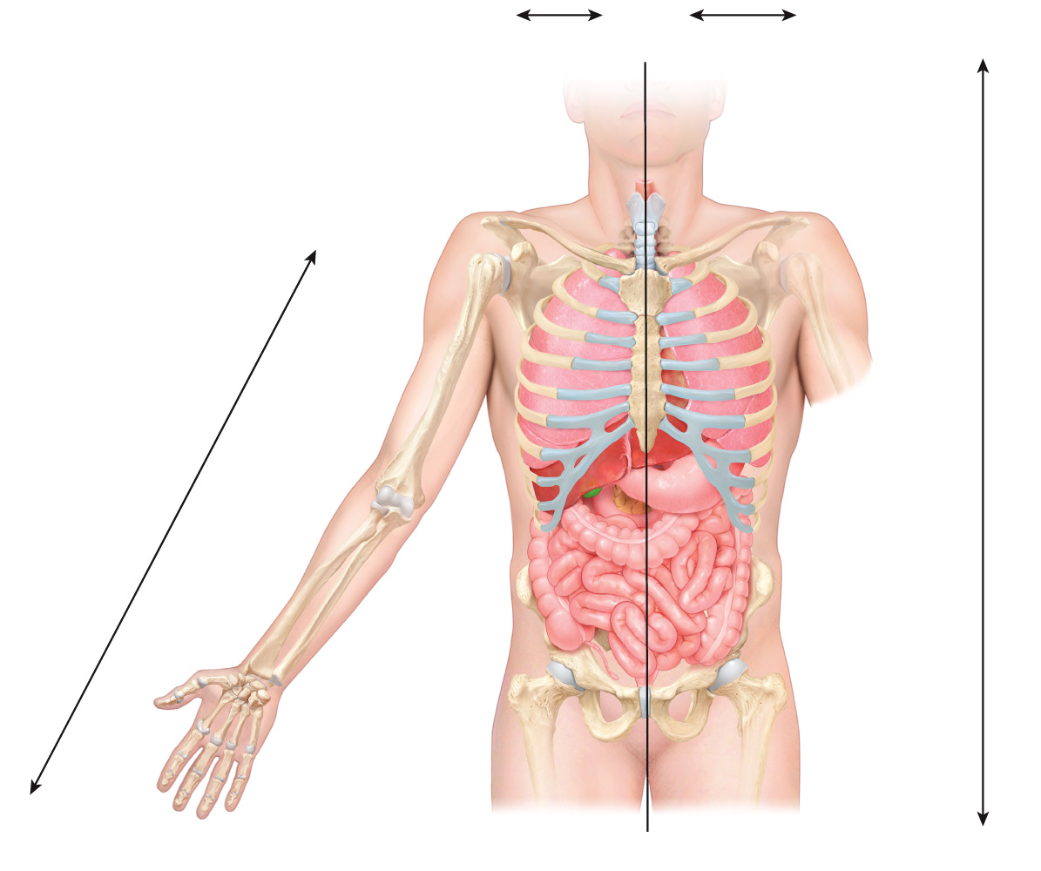
Answer: (do not include with question- for reference only)
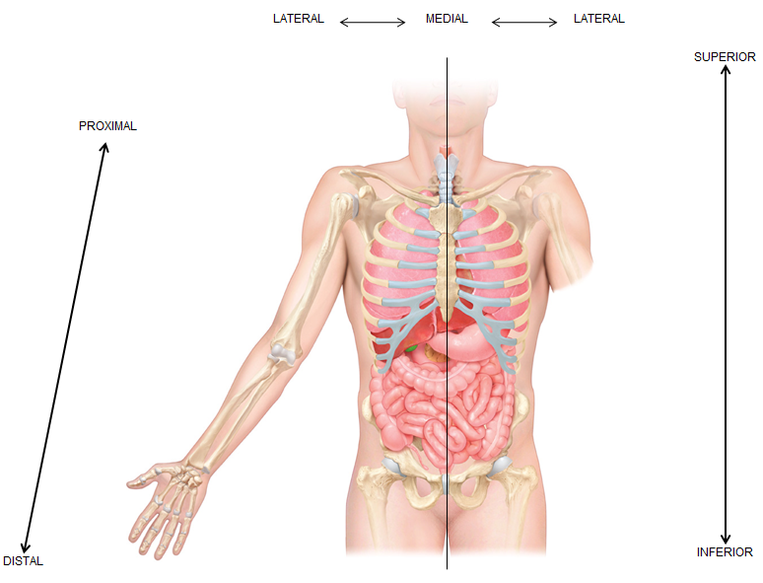

Difficulty: Medium
Bloomcode: Application
Learning Objective 1: LO1.5.3 Define the anatomical planes, anatomical sections, and directional terms used to describe the human body.
Section Reference 1: Sec 1.5 Basic Anatomical Terminology

Question Type: Text Drop Down

84) When the body is in correct anatomical position, the upper appendages are _______to the heart. The 3rd digit is __________to the 2nd and 4th digit. The 5th digit is ________to the 1st digit.

Drop Down Choices:
Lateral
Medial
Intermediate
Inferior
Superficial

Answer 1: Lateral
Answer 2: Intermediate
Answer 3: Medial

Difficulty: Hard
Bloomcode: Synthesis
Learning Objective 1: LO1.5.3 Define the anatomical planes, anatomical sections, and directional terms used to describe the human body.
Section Reference 1: Sec 1.5 Basic Anatomical Terminology

Question Type: Text Entry

85) If you eat a funnel cake, the following (simplified) events will occur:
Glucose from the carbohydrates is absorbed in the intestine and the level of glucose in blood rises. Blood glucose levels rise and stimulates beta cells in the pancreas to release insulin; while simultaneously inhibiting alpha cells release of glucagon. Insulin has a major effect of facilitating the movement of glucose into many cells, such as the liver; as a result, blood glucose levels fall. When blood glucose levels drop, the stimulus for insulin release disappears and insulin is no longer secreted.

What type of feedback is occurring? ______
What is the stimulus? ______
What are the receptors? ______
What is the output? ______

Answers:
Negative
Increased glucose levels in blood
Beta cells
Insulin
**extra answers
Positive
Decreased glucose levels in blood
Alpha cells
Glucagon

Difficulty: Hard
Bloomcode: Evaluation
Learning Objective 1: LO1.4.3 Contrast the operation of negative and positive feedback systems.
Section Reference 1: Sec 1.4 Homeostasis

